Supply List for String Piecing Reimagined Class

by Ilene Bartos

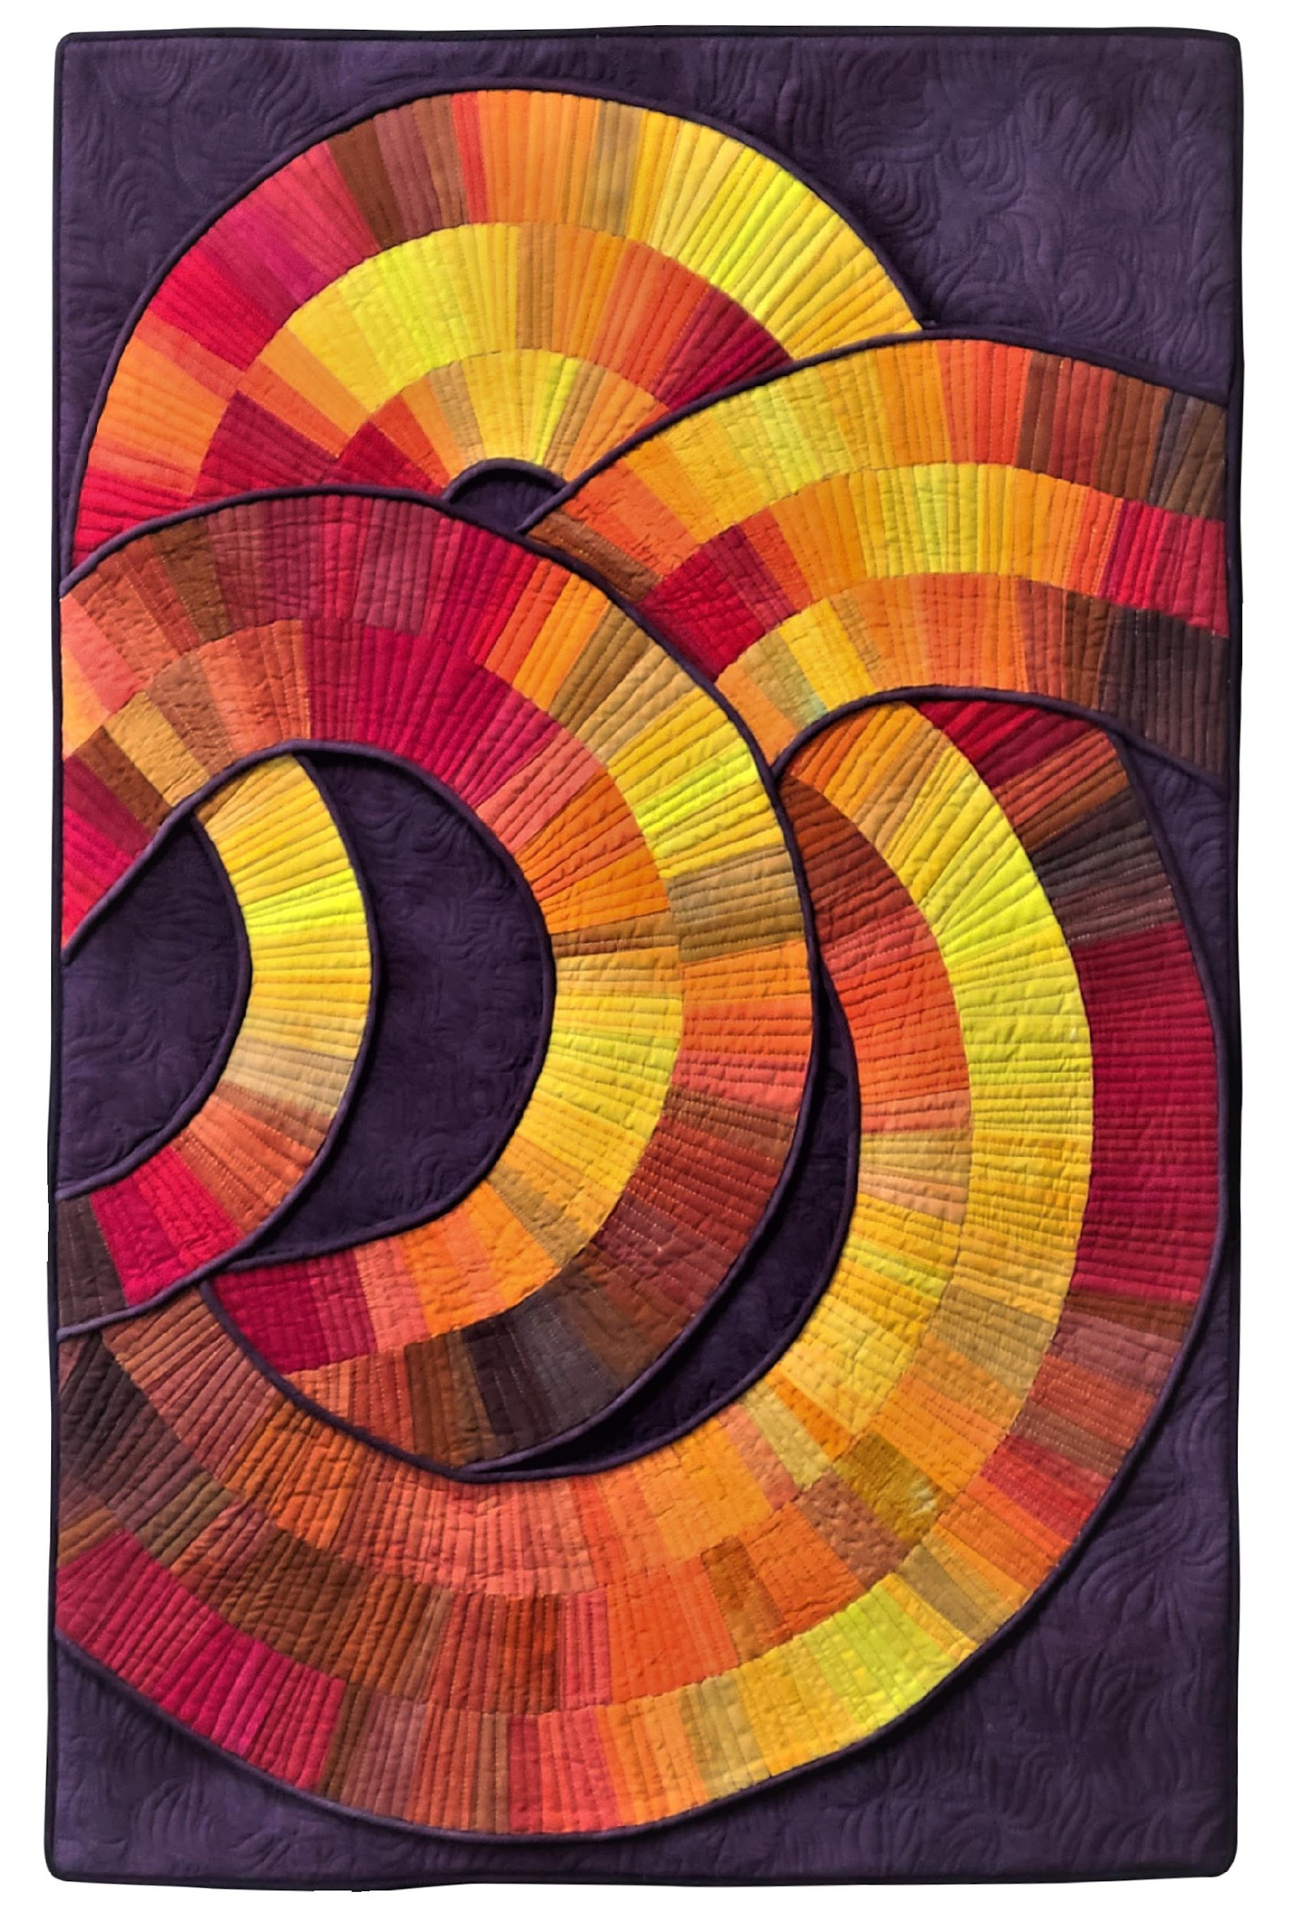 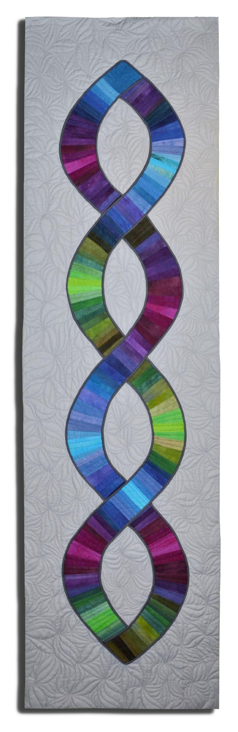 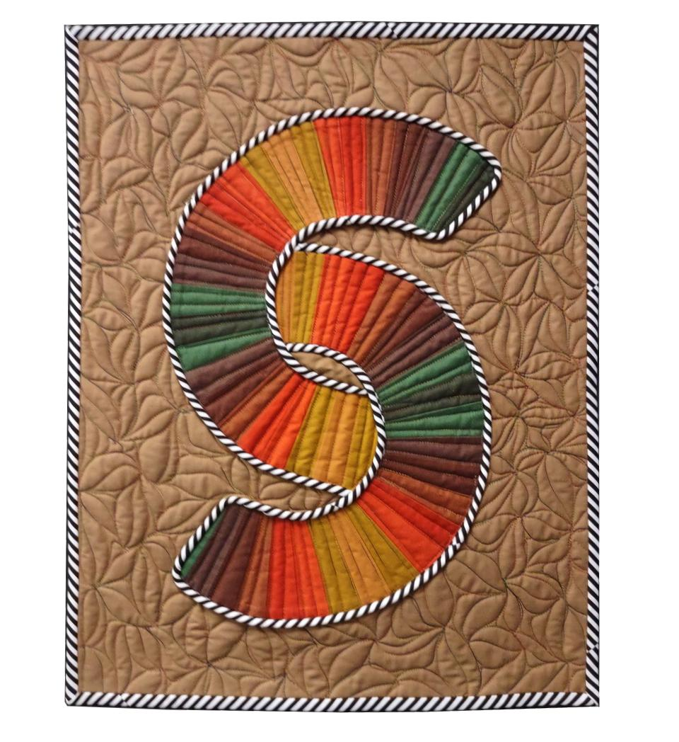 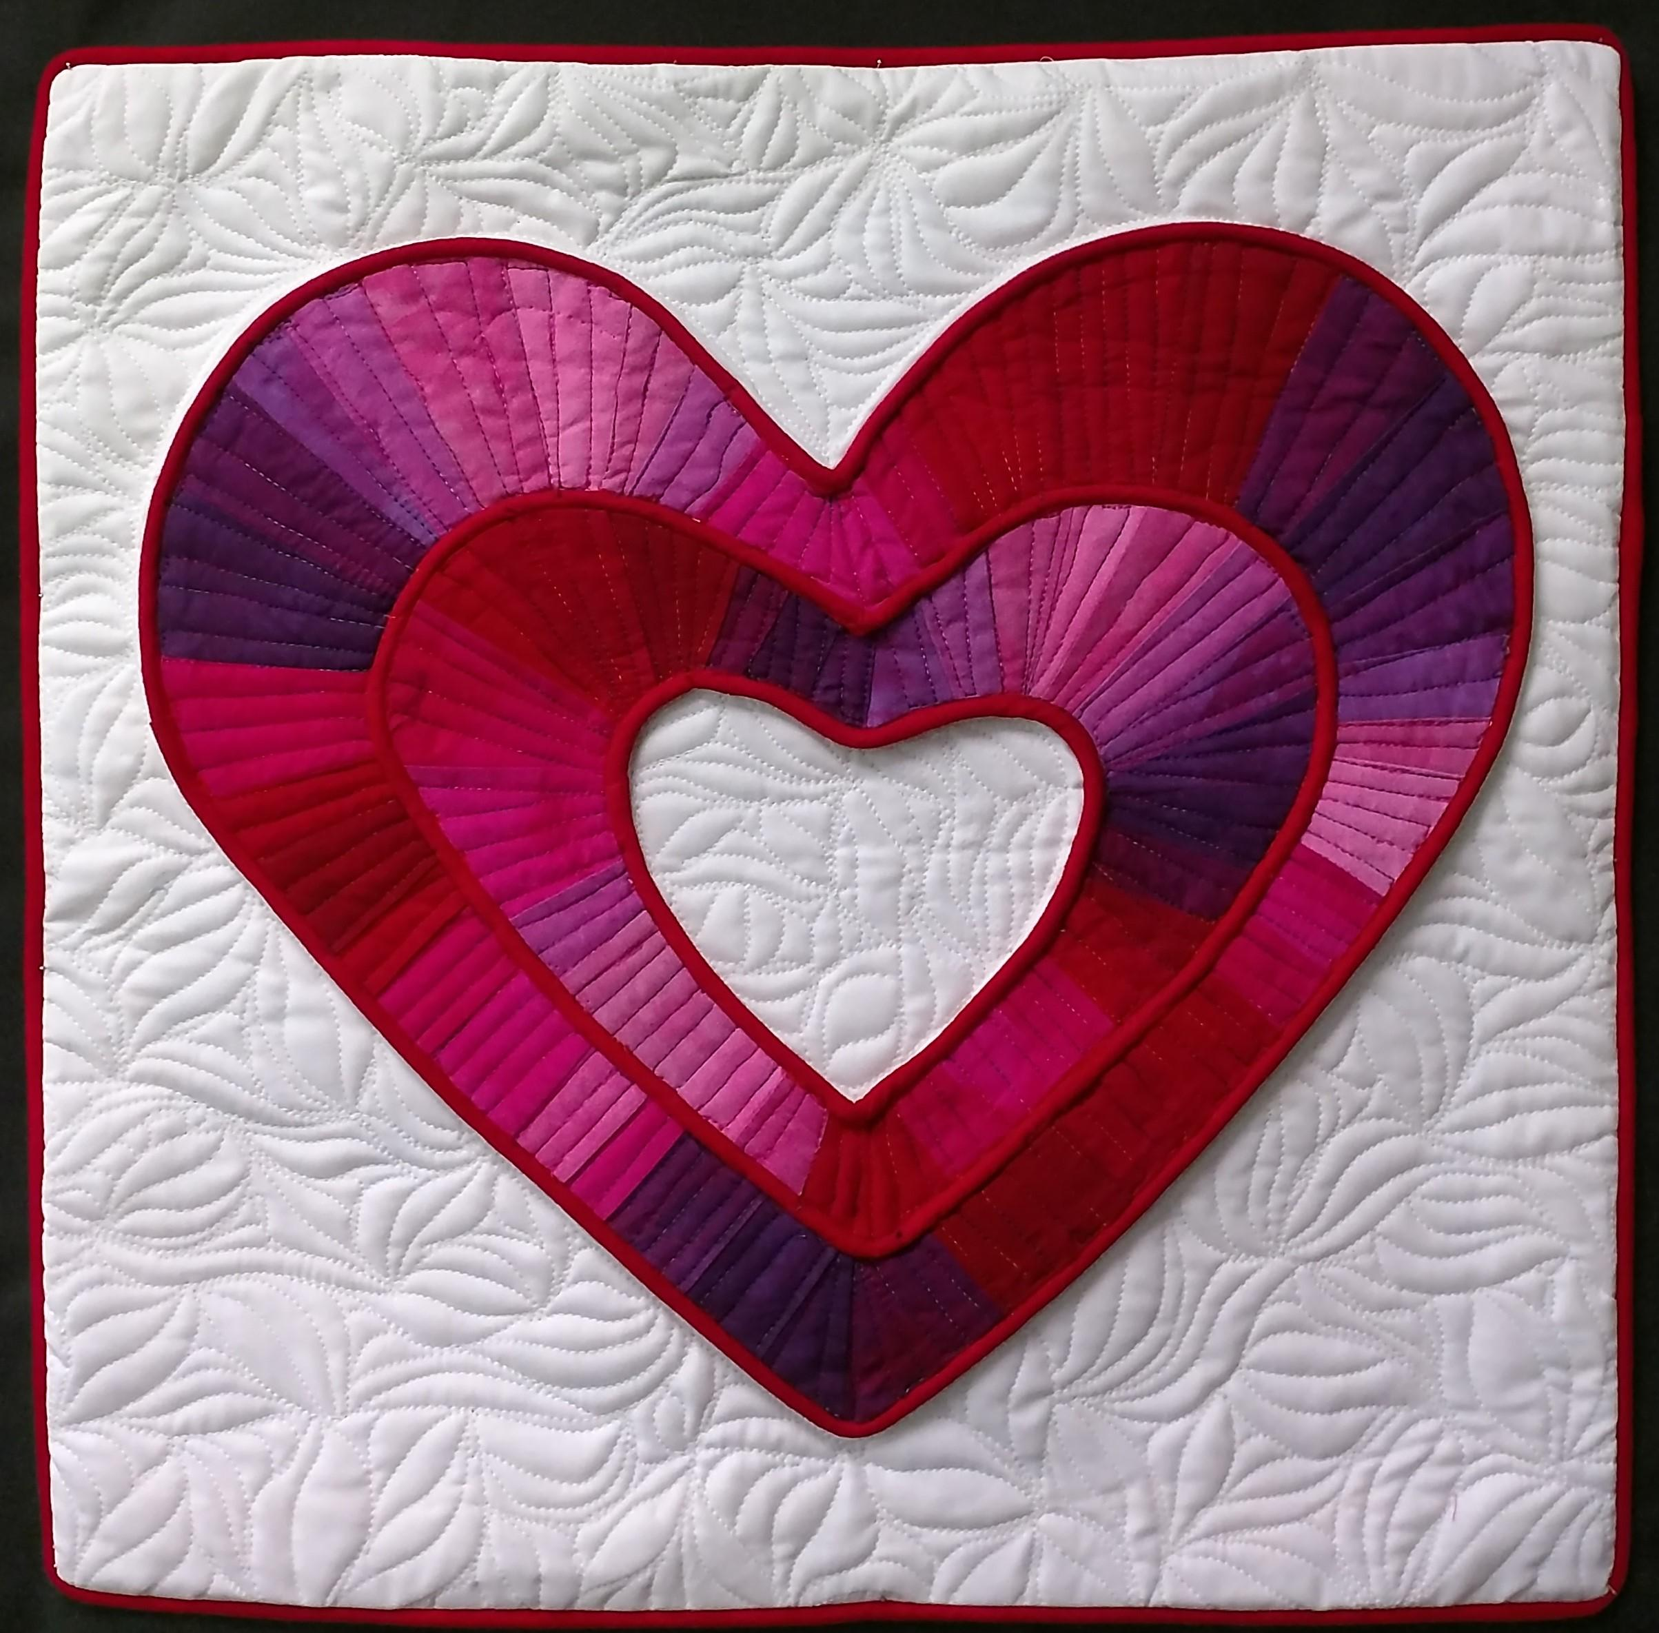

Arcs Helix Connected (2 color ways) Hearts

* Sewing Machine that can zigzag, with normal attachments; but include the following:
  + Cording or Piping Foot (for Bernina use 12 or 12E)
  + Darning or Free-Motion Quilting Foot (Only if we get to the quilting)
* Extension cord and/or power strip (unless these are provided for us)
* Personal Iron and ironing mats if possible
* Personal rotary cutter, mat, rulers if space allows
* Thread to blend with the various colors you use – medium grey or beige
* Small ruler for trimming strips like an Add-A-Quarter Inch Ruler
* Scissors – both paper and fabric
* Pencils for marking / thin line sharpie
* Glue Stick
* Lightweight Stabilizer – 2-3 yards (i.e., Pattern Ease)
* Pattern for the project of your choice (will be available at class)
* Fabric: 2½” Strips of a variety of colors for the arcs. These can be the same colors I used or different, depending on your preferences.
* Helix Background: 1 yard gray, cut in half and stitched together (21”x72”)
  + Piping: 1/3-yard darker grey. 3/16” Cording: 8.5 yards – 3 strip sets
* Arcs Background and Piping: 1¼ yard of dark purple or navy.
  + 3/16” Cording: 12 yards – 4 strip sets
* Hearts Background: 2/3 yard white.
  + Piping: 1/3-yard red. 3/16” cording: 6 yards – 3 strip sets
  + Connected Background: Fat Quarter
  + Piping: 1/3-yard black and white stripe. 3/16” cording: 3 yards –

Nine 1-1/2” strips

* Kits and/or Patterns will be available for purchase at the class. The kits **include**the pattern and everything below the middle line.
  + Helix: Kit $86 (pattern only: $35)
  + Arcs: Kit $98 (pattern only: $32)
  + Hearts: Kit $63 (pattern only: $20)
  + Connected: Kit $45 (pattern only: $15) In two colorways