Supply List for

Fall Leaf Class by Ilene Bartos

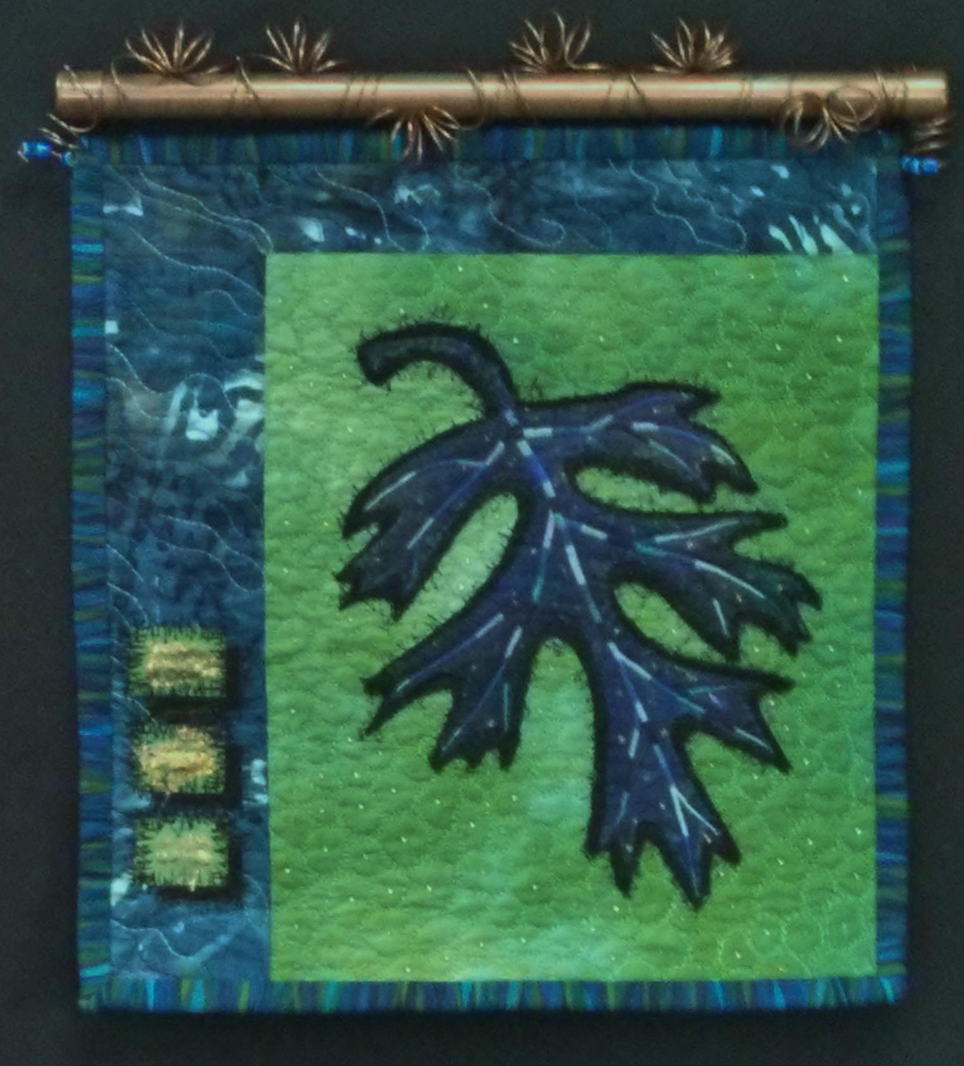 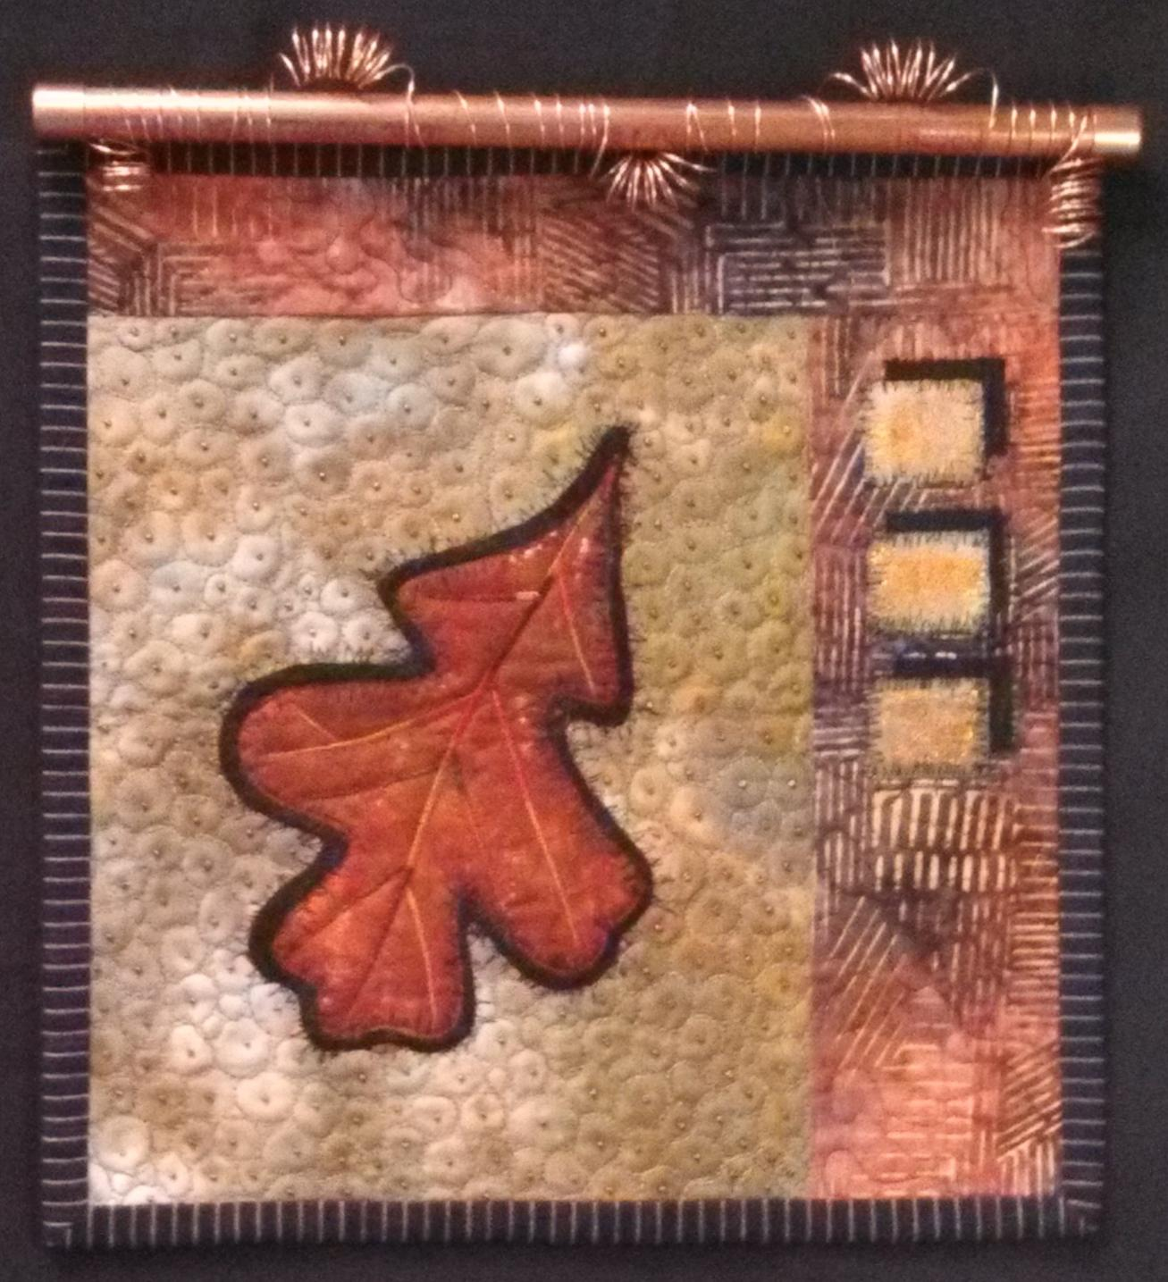 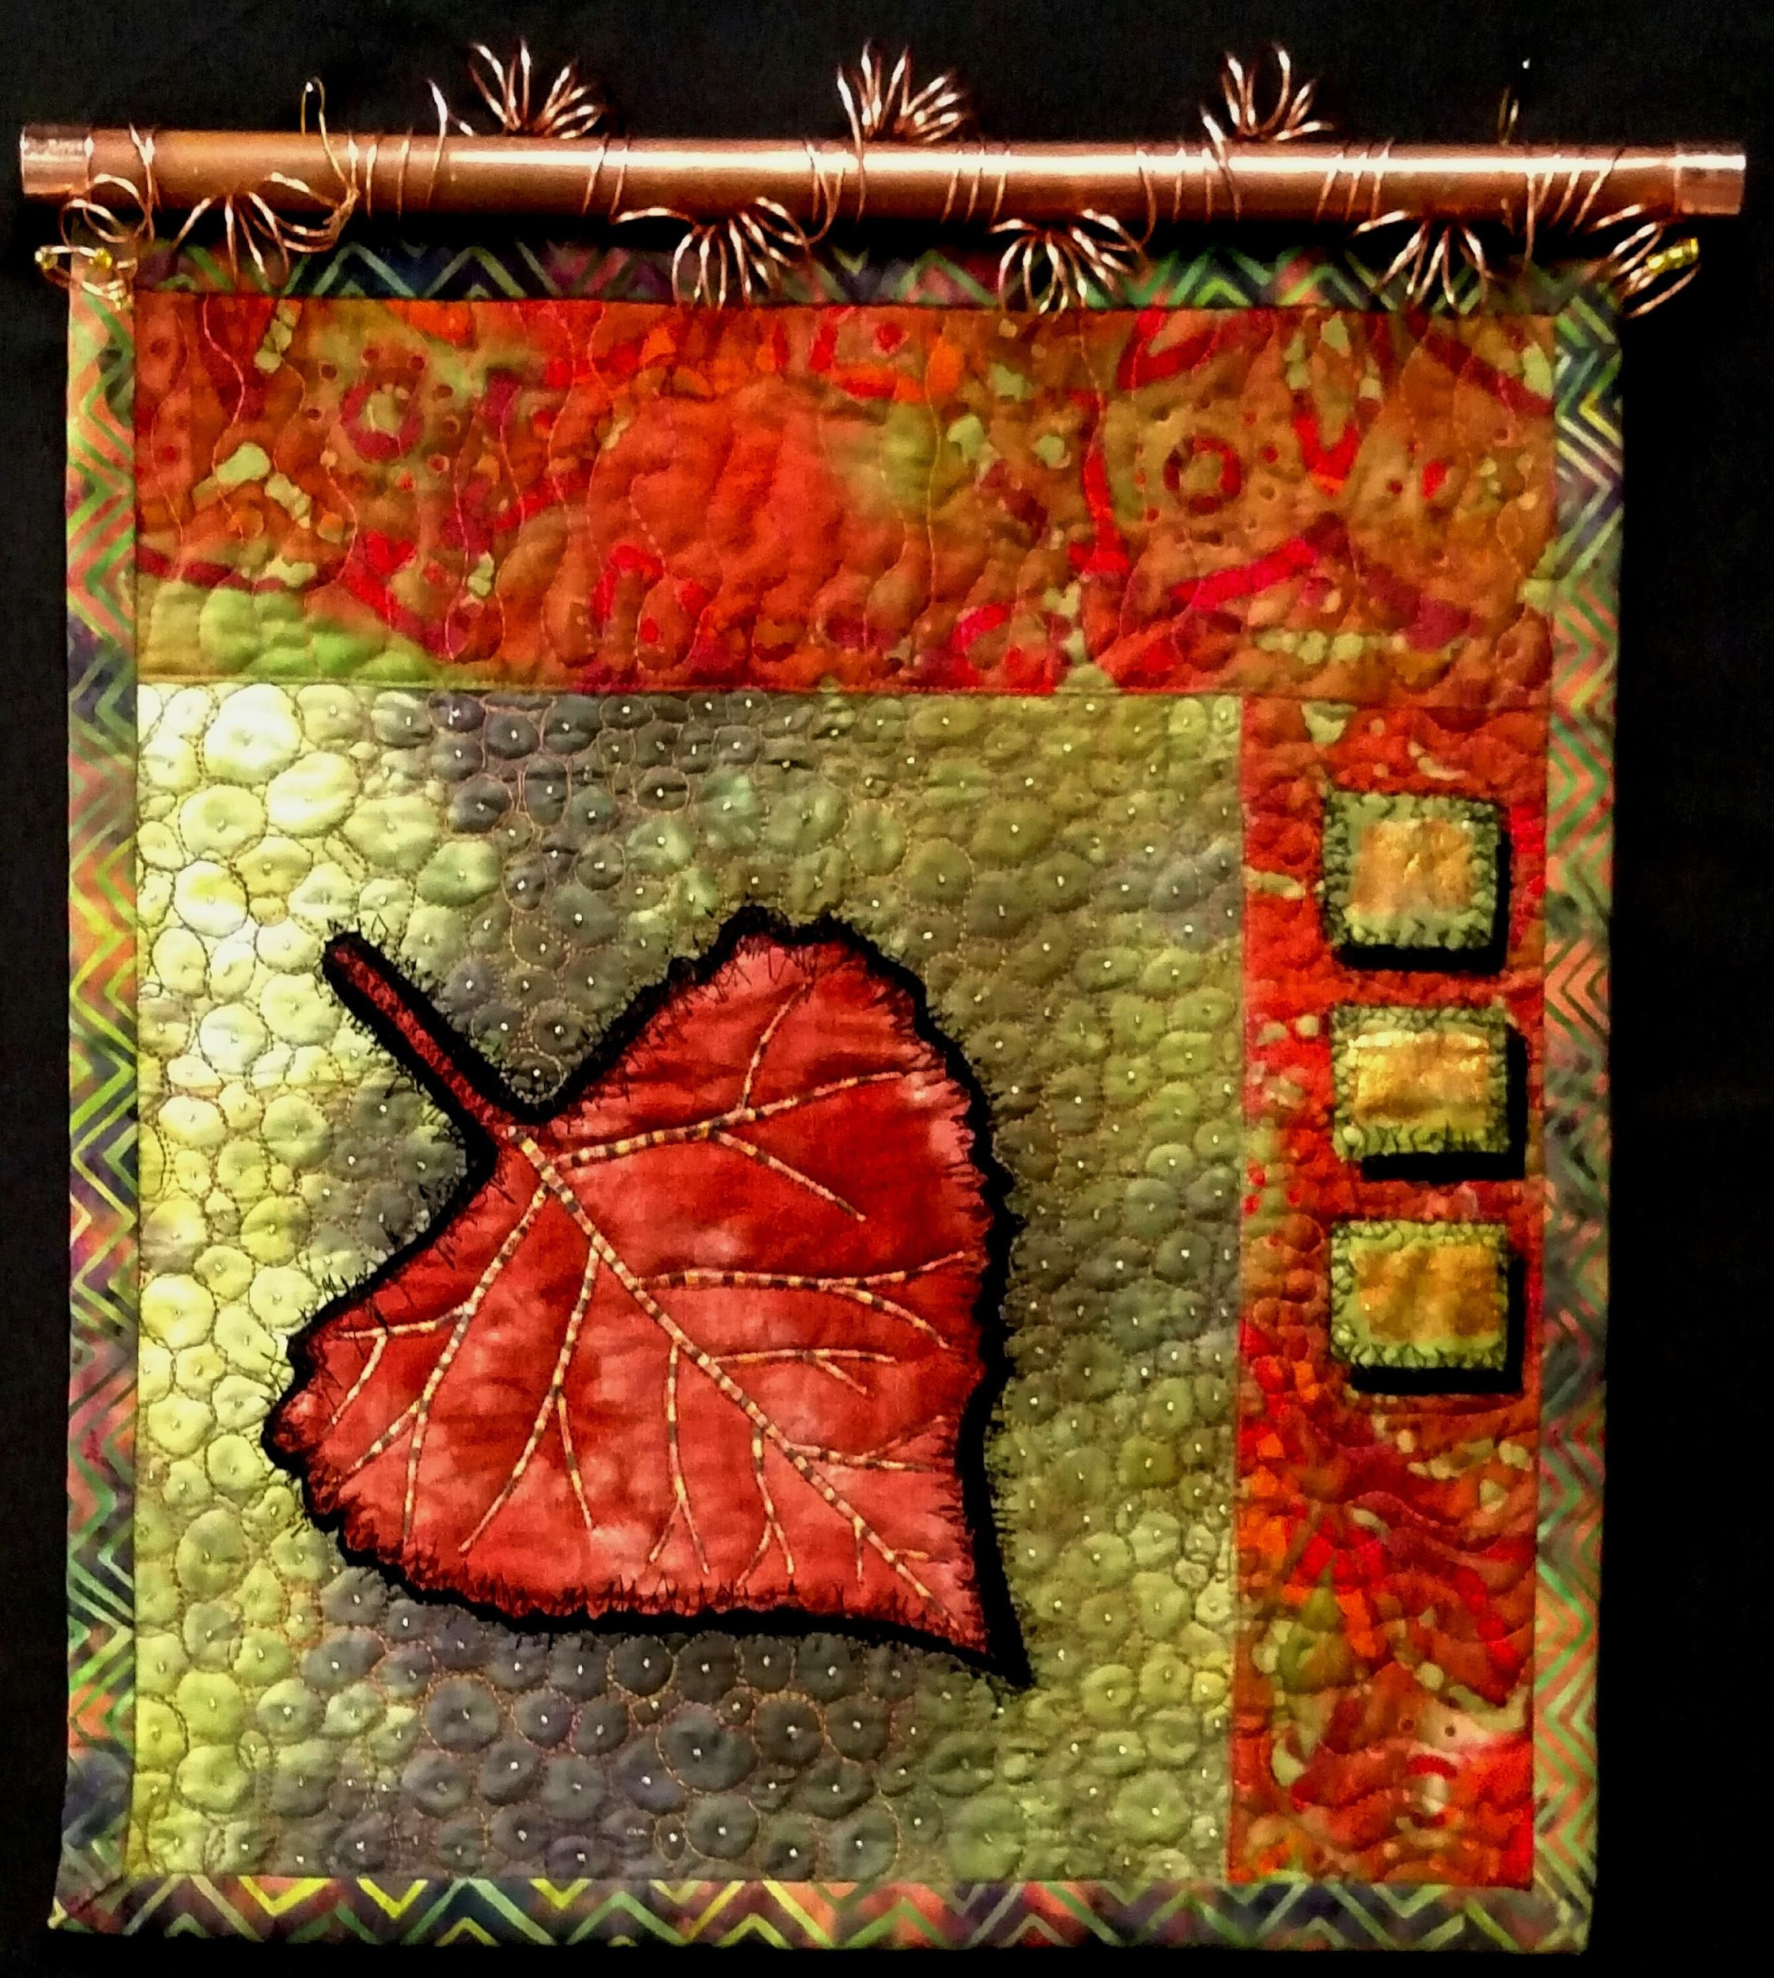 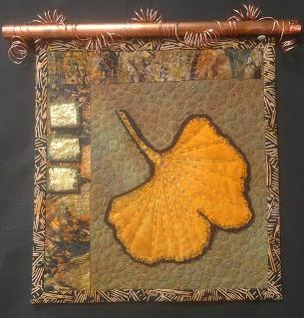 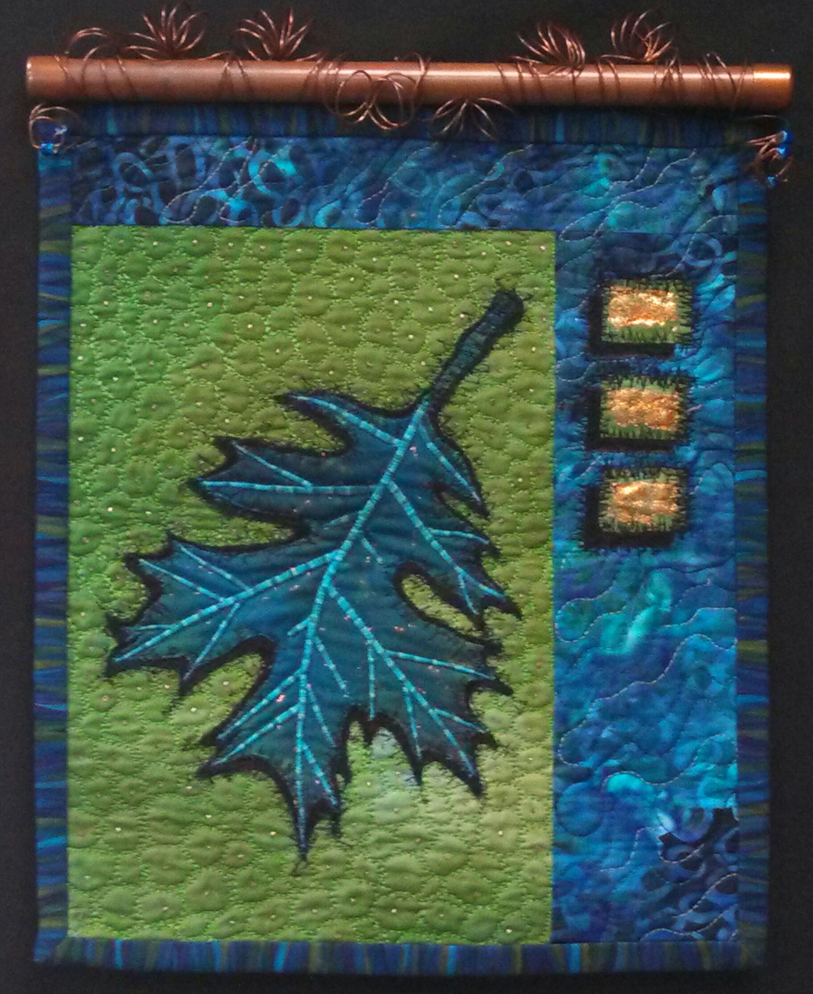 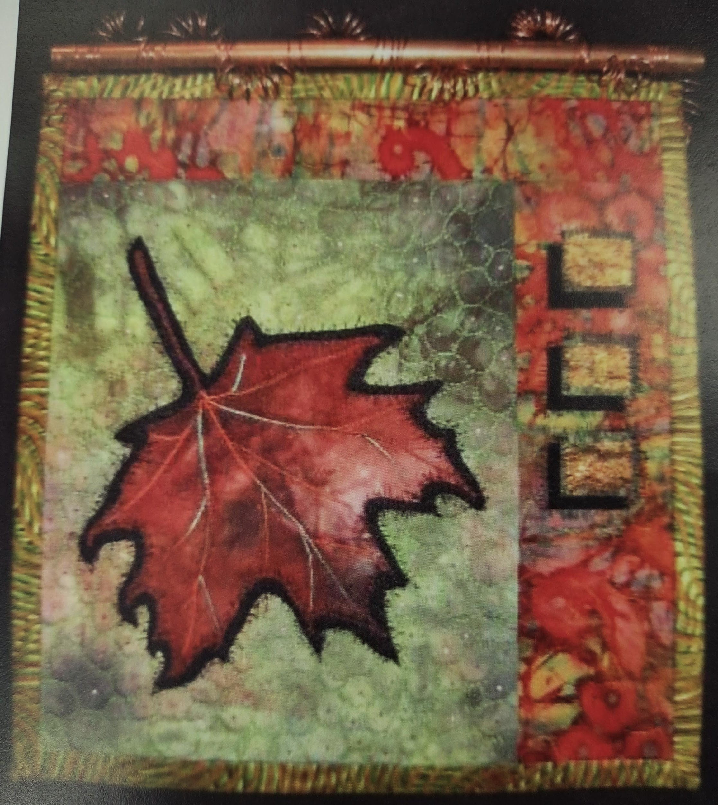

* Sewing Machine that can zigzag, with normal attachments; but include the following:
  + Open Toe Foot AND Darning or Free-Motion Quilting Foot
* Iron and ironing board if not provided
* Threads:
  + Variegated thread for vein lines
  + Black Thread
  + Quilting thread to match background
  + Quilting thread to match border fabric
  + Thread to match the leaf fabric
* Rotary cutter, mat, ruler
* Scissors – both paper and fabric
* Appliqué Pressing Cloth or Parchment paper
* Marking chalk/pencils
* Freezer Paper – approximately 12” x 12”
* Stabilizer – approximately 12” x 12”
* Batting - approximately 18” x 18”
* Fat Quarter for Backing
* Spray Adhesive like KK2000
* 12½”x 12½” square ruler for trimming