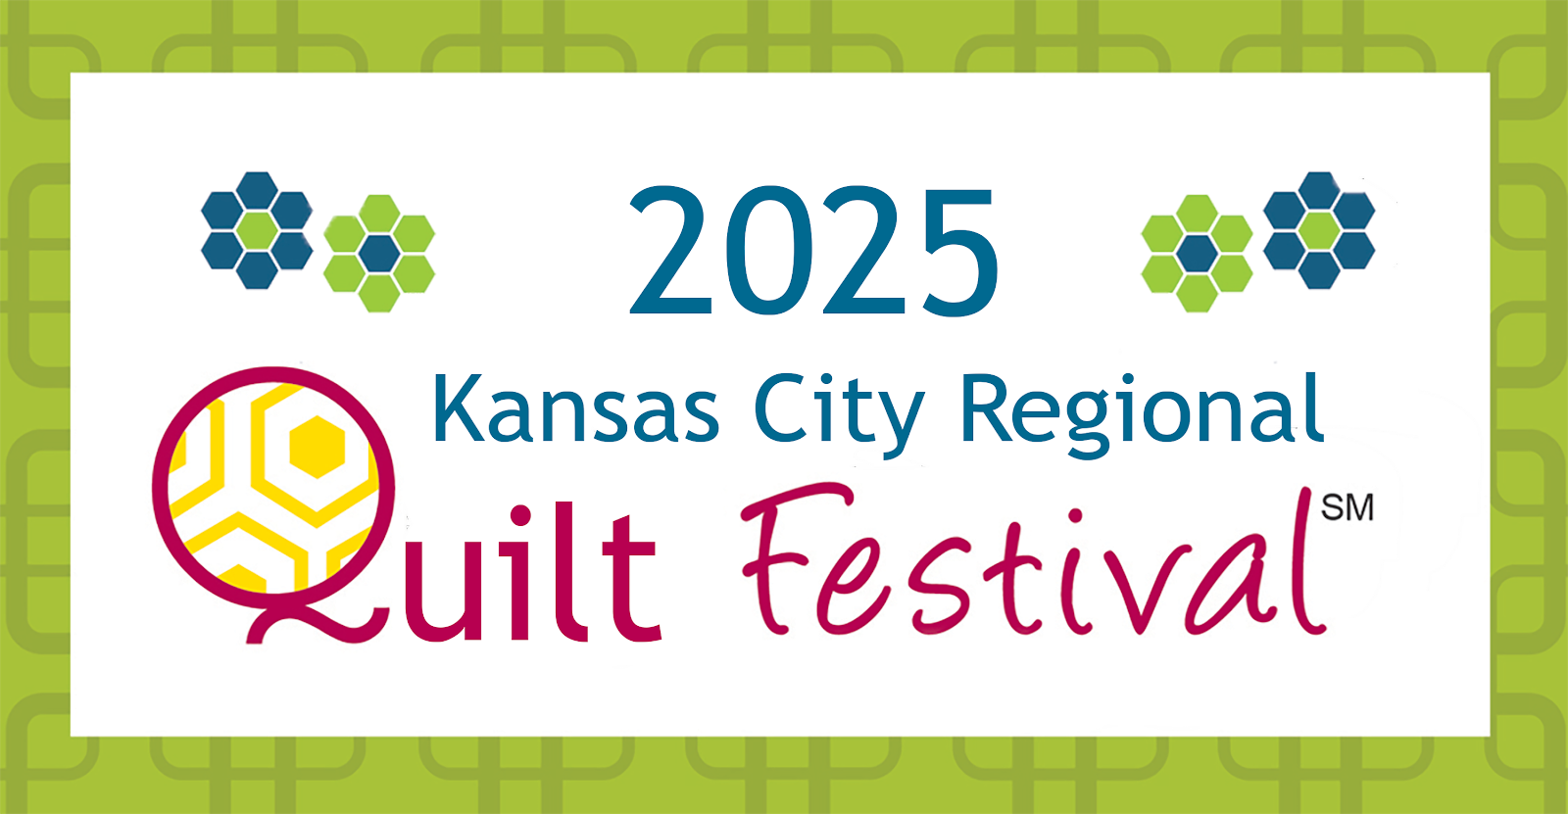
KANSAS CITY REGIONAL QUILT FESTIVAL
YOUTH CLASSES
RELEASE AND WAIVER OF LIABILITY AND INDEMNIFICAITON AGREEMENT

• I am the legal parent or guardian of _______________________ (“Student”) that will be participating in one or more of the youth classes offered by Kansas City Regional Quilt Festival (“KCRQF”).
• I am aware that the classes may involve using equipment and tools (e.g. scissors, sewing machines) that can cause injury.
• I understand that it is my responsibility to decide if Student is qualified to participate in the activities, and I assume all risks, including any injuries to Stu\dent, and accept personal responsibility for any potential damages arising from their participation.
• I will instruct Student to carefully listen to and follow all safety and other instructions and to inform the instructor or KCRQF volunteer if they are uncomfortable in the operation of the sewing machines or use of any equipment or tools.
• If Student is injured in any way during the youth class and I am not present, I give my consent to have the KCRQF or any medical personnel help in the way they see fit. I’m aware that the cost of any medical transportation or assistance will be my own responsibility.
• I understand KCRQF may take group and individual photos (or videos) of Student participating in the activities for use (without identifying information such as Student’s name) on the website, in brochures, and other marketing, and I allow KCRQF to do this without any compensation.
• I agree to hold harmless KCRQF, including their instructors and volunteers, for any issues that arise from Student participating in the youth classes and activities.
Student Name: ______________________________________________Student Age: _______
Parent / Guardian Name:_____________________________________________________
Signature: ___________________________________________ Date: ___________________
Address: ___________________________________ City:_________________________________ Zip:__________
Emergency Contact (cell): (_______)_______________________

